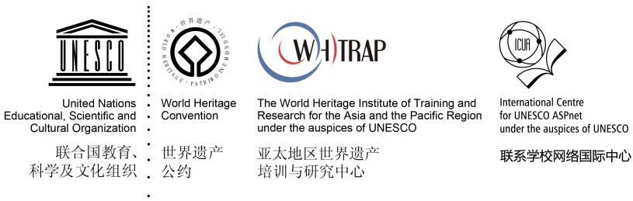

AHHEIC
CESSION OF RIGHTS AND DECLARATION FORM

- CESSION OF RIGHTS
I, the undersigned ,as legitimate authorized representative of , (enterprise/institute/organization, local community representatives, indigenous people representatives, hereby grant to WHITRAP, Global Awards for World Heritage Education Innovative Cases (AWHEIC) and its authorized partners the non-exclusive rights to use, publish, reproduce, distribute, display, communicate or make available to the public all the application materials, in any language or form and by and means including digital, the following material(s), in whole or in part. I grant these rights to WHITRAP irrevocably, for an unlimited period of the time and for the entire world.
The non-exclusive cession of rights does not impinge upon intellectual property rights (rights of the photographer / director of the video or copyright owner if different) and that when the images are distributed by WHITRAP a credit to the photographer / director of the video is always given, if clearly provided in the form.

- DECLARATION FORM
I, the undersigned ,as a legitimate authorized representative of
(enterprise/institute/organization, local community representatives, indigenous people representatives), hereby
- declare that all the information provided in the entry materials is accurate.
2) Confirm that all entry materials provided is in no way involved in any legal disputes;
3) confirm that all entry materials are in no way whatever a violation or an infringement of any existing copyright or license, or is/are my own property or have provided with the full consent of the authors/original owners.
Any links to external websites and/or information provided by WHITRAP web are not be construed as an endorsement by WHITRAP of the content or views of the linked materials.

Signature of the authorized representative:
applicant:
Date:

