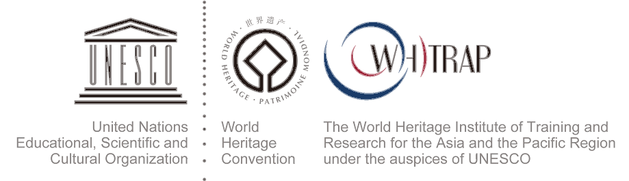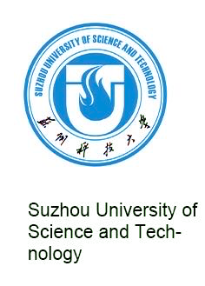

2023 ADVANCED COURSE ON CONSERVATION AND RESTORATION TECHNIQUES OF TRADITIONAL ARCHITECTURE FOR THE ASIA-PACIFIC REGION—
COGNITION AND ACTIVATION OF THE CULTURAL HERITAGE OF THE GRAND CANAL IN CHINA FROM A COMPOSITE PERSPECTIVE

Application Deadline: SEPT 18th, 2023

Duration: October. 8-14, 2019
Place: Suzhou, P.R.China

Organizers:
The course is organized by:
- World Heritage Institute of Training and Research for Asia and the Pacific Region under the auspices of UNESCO (WHITRAP) Suzhou Centre
- Suzhou University of Science and Technology
- Suzhou Grand Canal Cultural Belt and Grand Canal Yangtze River National Cultural Park Construction Leading Group Office

In collaboration with:
- Zhejiang Provincial Institute of Cultural Relics and Archaeology
- China Grand Canal Museum

Academic supported by:
Committee of Urban Rural Built Heritage -ASC

Host：
School of Architecture and Urban planning, Suzhou University of Science and Technology

Background
The Grand Canal in China (GCC) stands as a vital repository of traditional Chinese culture. Examining how to facilitate the reconstruction of collective memory and promote sustainable local development through the systematic understanding and activation of its heritage is a significant topic within the field of historical environment conservation. In the meantime, the cultural heritage of the GCC is intricately intertwined with the local traditions as well as the historical, cultural, economic, political, ecological landscapes of the towns along its banks. This has given rise to a multi-layered waterfront cultural heritage corridor. The establishment of research to this corridor has expanded our comprehension and appreciation of this particular heritage category. In the contemporary context, as heritage concepts and values increasingly enriched, a multifaceted and multidimensional composite perspective is poised to provide new avenues for deepening our cognition of the GCC and for scientifically realizing the symbiotic activation of heritage and local development.

WHITRAP together with Suzhou University of Science and Technology are pleased to announce that the Advanced Course on Conservation and Restoration Techniques of Traditional Architecture in the Asia-Pacific Region 2023—COGNITION AND ACTIVATION OF THE CULTURAL HERITAGE OF THE GRAND CANAL IN CHINA FROM A COMPOSITE PERSPECTIVE will be held from October 8th to 14th, 2023.

Course content
In the forthcoming edition of the course, the main topic is “COGNITION AND ACTIVATION OF THE CULTURAL HERITAGE OF THE GRAND CANAL IN CHINA FROM A COMPOSITE PERSPECTIVE”:
The course will center around the theme of examining the historical composition and contemporary perception of the heritage value of the GCC within the context of a composite perspective. Through international and domestic case studies including the cultural heritage value of the Grand Canal of Venice; historical composition and contemporary significance of the key sections along the GCC including regions in Suzhou, Yangzhou, Hangzhou; this advanced training course invites participants to explore the activation strategies of canal culture heritage for urban cultural rejuvenation.

Main Content：
- Review and innovation on the paradigmatic approach in the Grand Canal cultural heritage research
- Comparative readings and studies on the value of the Grand Canal as a world cultural heritage site
- Interpreting and understanding key areas of the Grand Canal cultural heritage (on-site course)
- The survey of the current relationship between the Grand Canal cultural heritage and urban communities (on-site course)
- International and domestic case studies on the multidimensional revitalization of waterfront architectural heritages
- Group work and course discussion

Objectives
- Understand the research history and methodology of the Grand Canal cultural heritage;
- Acquire knowledge of the multifaceted heritage value of the Grand Canal from a composite perspective;
- Enhance the understanding of the evolution and development of the Grand Canal cultural heritage;
- Enhance the understanding of the healthy relationship between the Grand Canal cultural heritage, historical culture and the natural ecology;
- Propose multidimensional revitalization design concepts/strategies for waterfront architecture and cultural heritage based on the case studies.

Methodology
Training will be based on various methodologies including lectures, case studies, site visits, group work and course discussion. During the course, participants will be instructed to share their own knowledge and experiences, to participate in case studies and group discussions to better understand the knowledge.

Application Requirements
This training program is primarily intended for technical and managerial professionals in China with relevant work experience in the field of cultural heritage preservation and restoration. The program is designed for a maximum of 25 participants. Priority is given to:
- Professionals directly involved in management and conservation of the Grand Canal preservation;
- Researchers/ technicians/ professional staff from institutes involved in the conservation and restoration of historic architecture;
- Professional staff from institutes involved in cultural conservation and tourism management of the Grand Canal;

Teaching Team
Members of the faculty include experts and professors from University of Virginia, Delft University of Technology, Peking University, Southeast University, Suzhou University of Science and Technology, Suzhou University, Nanjing Museum, China Grand Canal Museum, Zhejiang Provincial Institute of Cultural Relics and Archaeology, and other well-known heritage conservation institutions. All experts have both academic and practical experience to introduce broad international perspectives, classic cases and up-to-date expertise and information.

Language
Chinese is the working language of the course. (partial international experts and professors in English, without translation)

Certificate of Attendance
A certificate of attendance authorized by organizers will be awarded to participants who successfully complete the course. Participants are expected to attend all lectures, site visits and reporting during the course.

Relevant fee
WHITRAP will cover relevant costs for all candidates during the course, including tuition fees (plus site visits), insurance, transportation fees (including the fee for the on-site courses as well as the transportation fees during the course), teaching materials. The candidates should pay transportation fees (round-trip ticket to Suzhou, CHINA), accommodations fees, meals and other expenses by themselves.

Application
Please fill the Application Form and send it together with all the soft copies listed below by mail to the contact address below before September 18th 2023:
- the application form (with handwriting signature and photograph);
- a full professional curriculum vitae;
- a copy of Chinese ID card or valid passport and other materials required for the visa;
- a piece of recommendation letter from the applicant’s organization (with company chop/official signature).
The Admission feedback after pre-evaluation will be released to the applicants and their organizations, institutions or companies.
WHITRAP reserves the rights for all application documents and presentations from participants.

Contact Information
Contact: Miss. Lin Lin
WHITRAP, Suzhou Centre
Address: 255, Garden Road, Gusu District, Suzhou, 215006, Jiangsu, P.R.China
Tel：+86-512-67552305, +86-512-67552106
Fax：+86-512-67552505
Email: whitrap_sz@foxmail.com

Contact: Miss. Chen Xiaohan
Suzhou University of Science and Technology
Tel: 15189822269
Email: c.xiaohan@yahoo.com

