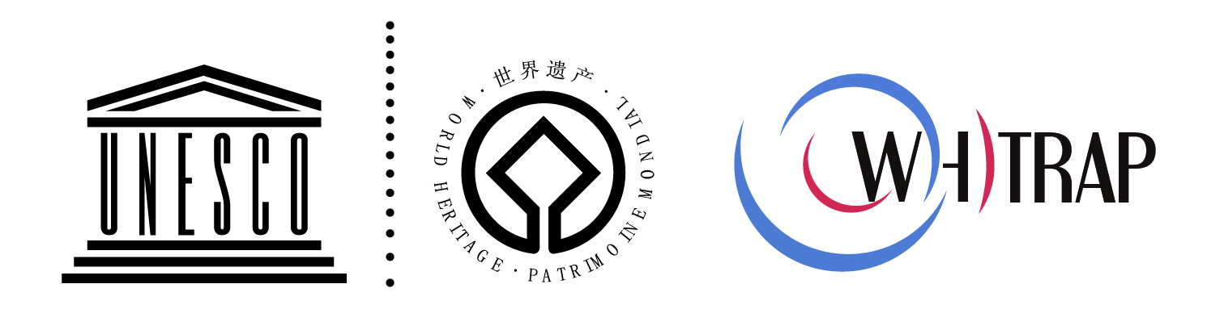

联合国教科文组织亚太地区世界遗产培训与研究中心（上海）
大学生兼职英文校译人员招募通告

World Heritage Training and Research Institute for the Asia and the Pacific Region (Shanghai)
Recruitment for Part-time English Translator or Proof-reader

- 中心简介

联合国教科文组织世界遗产培训与研究中心（亚太地区）（以下简称中心）是联合国教科文组织的二类国际机构，是在发展中国家建立的第一个遗产保护领域的此类机构。它服务于亚太地区《世界遗产公约》缔约国及其他联合国教科文组织成员国，致力于亚太地区世界遗产的保护与发展。
中心由北京、上海、苏州三个子中心构成，其中，上海中心（同济大学承办）主要负责文化遗产保护相关项目，包括城镇、村落保护与可持续发展、建筑/建筑群/建筑遗址保护以及文化景观保护等；北京中心（北京大学承办）主要负责自然遗产保护、考古发掘以及文化景观管理；苏州中心（苏州市政府承办）主要负责职业技术人才培训和以遗产地管理和修复技术为主的研究活动。

Introduction to WHITRAP

The World Heritage Training and Research Institute for the Asia and the Pacific Region (WHITRAP) is a Category II institute under the auspices of UNESCO. It was the first international organization in the field of world heritage to be established in a developing country. Mandated by the State Parties of the World Heritage Convention and other State Parties of UNESCO, the institute was founded to promote the conservation and development of World Heritage in the Asia and Pacific Region.
WHITRAP has three branches: one in Beijing, another Shanghai, and the third in Suzhou.
The Shanghai Centre at Tongji University focuses on the conservation of cultural heritage, such as the sustainable development of ancient towns and villages, architectural sites, architectural complexes, and cultural landscapes.
The Beijing Centre at Peking University is in charge of natural heritage conservation, archaeological excavation, and management of the sites’ cultural landscape.
The Suzhou Centre, hosted by Suzhou Municipal Government, provides technical training and researches site management methods and restoration techniques.

- 招募内容

- 招募岗位/ Position
- 大学生兼职英文校译人员。
Part-time Translator or Proof-reader
- 工作地点不限，主要以邮件方式处理工作。
Working place is not limited. The work can be done by email.

- 对象要求/ Requirements
- 母语为英语
Mother Language: English
- 限美国、英国、加拿大国籍留学生
Only to USA, UK, and Canada foreign students
- 有一定中文读写能力者优先录用
Priority gives to those who can read and write Chinese

- 工作内容/ Job Description
- 负责中心各类英文稿件的校译工作。
Translate or Review all kinds of English documents.
- 工作量及工作时间由中心根据实际需要，事先与兼职人员沟通后再行确定。
Amount of work depends on the situation. It can be discussed before work.

- 福利报酬/ Payment and Benefit
- 按工作量支付报酬。
The payment is given based on the amount of work.
- 兼职人员享受与中心志愿者同等福利待遇，包括：可免费阅览中心藏书（不外借）；可获赠中心Newsletter及部分出版物；结合兼职人员个人条件、工作表现及对中心的贡献度，在条件允许范畴，为其提供各类培训与学习机会，如参与中心主办的会议、培训、讲座及其他活动等。
Benefit includes: Free use of Archives (the book can not be borrowed outside Archives); Free Newsletter and other publications; Based on the contribution and working performance, under some certain conditions, training and study opportunity can be offered, for example, conferences, trainings, lectures and other activities organized by WHITRAP Shanghai.

- 报名方式/ Contact
- 请完整填写附件《申请表》，Email至whapshanghai @gmail.com 李泓 老师 收。
Please fill in the Application Form and send to Ms. LI Hong (whapshanghai@gmail.com).
- 本通告长期有效。
The recruitment becomes into effective for long period.

附：《申请表》
Appendix: Application From

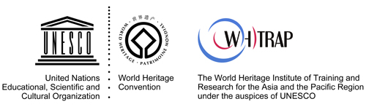

Photo

APPLICATION FORM

First Name |  | Family Name
Nationality |  | Gender
ID/ Passport No. |  | Birthday(dd/mm/yy)
Email Address |  | Mobile Phone
Postal Address
Address in Shanghai
University |  |  | Degree
Major

