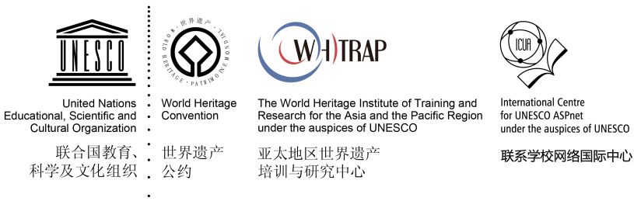

AWHEIC
CESSION OF RIGHTS AND DECLARATION FORM

- CESSION OF RIGHTS
I, the undersigned , as legitimate authorized representative of , enterprise/institute/organization, local community representatives, indigenous people representatives, hereby grant to the organizers of Global Challenge for World Heritage Education Innovative Cases (AWHEIC) and its authorized partners the non-exclusive rights to use, publish, reproduce, distribute, display, communicate or make available to the public all the application materials, in any language or form (including digital form) , the following material(s) in whole. I grant these rights irrevocably, for an unlimited period of the time and for the entire world.
The non-exclusive cession of rights does not impinge upon intellectual property rights (rights of the photographer / director of the video or copyright owner if different) and that when the images are distributed by the organizers of AWHEIC and its partners a credit to the photographer / director of the video is always given, if clearly provided in the form.

- DECLARATION FORM
I, the undersigned ,as a legitimate authorized representative of
(enterprise/institute/organization, local community representatives, indigenous people representatives), hereby
- declare that all the information provided in the entry materials is accurate；
2) Confirm that all entry materials provided are in no way involved in any legal disputes；
3) confirm that all entry materials are in no way whatever a violation or an infringement of any existing copyright or license or is/are my own property or have provided with the full consent of the authors/original owners.

Signature of the authorized representative:
Applicant:
Date:

Note: This Form has Chinese and English version, the Chinese version shall prevail, annexed below.

